**Inventory System – iOS Application**

User Manual for Basic User

**Vision Quest**

Sai Suneel Reddy Challa

Jeevitha Kamatham

Manoj Kumar Kotte

Meghana Thakkellapati

Sahithya Vuppala

Date: 04/16/2017

Prepared for

44-692 Computer Science Graduate Directed Project – I

Spring 2017

Instructor: Zhengrui Qin

Client: Zhengrui Qin

1. **Introduction:**

This is an iOS Mobile application that helps a businessman manage his online store.

**Configuration:**

This is an iOS Mobile application, which supports for all kinds of iPhone like iPhone 6, iPhone 6s and iPhone 6 plus with OS version of minimum 9.0

1. **Installation Instructions:**

**Step-1:** Download Xcode from App Store into your Mac system. Launch the .dmg file you downloaded. Follow the setup wizard to install Xcode Studio.

**Step-2:** Download inventory iOS project provided

**Step-3:** Select the device you want to run on at the top left corner of Xcode and click on run icon to build and run the app. The app runs on the simulator and can use the app.

**Step-4:** To deploy the app on your mobile device. Connect your mobile device and and select your mobile device under simulator. Run the app, you will be asked to enter the developer credentials. Enter your credentials, app gets deployed in the mobile device and you can use it.

1. **Basic user:**
   1. **Registration:**

* The new user have to register/ create account first. The application first launches the login screen, where there will be an option “Guest”.
* The new user now will be redirected to a home page where the details about the application is provided. If the user wants to join the application then he can click joinUs button.
* When user clicks on it, he/she will be navigated to the registration screen.
* The user registers by providing information like full name, e-mail id, username, password etc. When user clicks on “Submit” button, the user will be successfully created an account and navigated to know your app screen.
* The user can cancel the registration by clicking on “cancel” button, which navigates to login page.

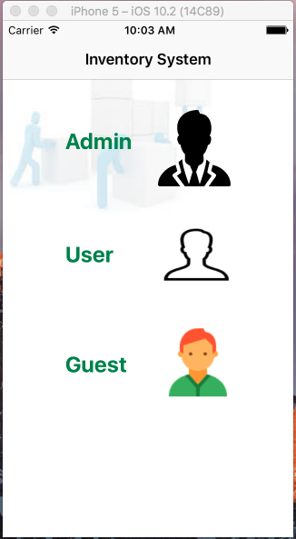

**Fig: 3.1.1 Home screen of the application**

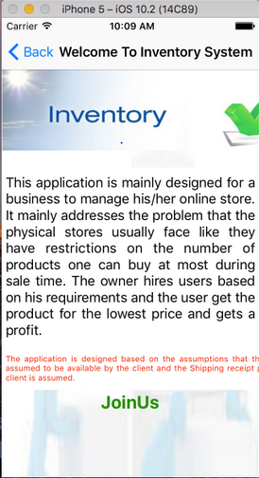

**Fig: 3.1.2 Guest Home screen**

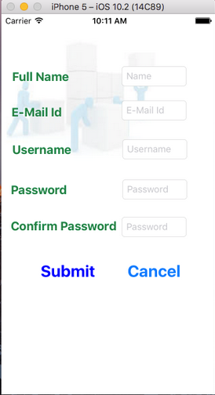

**Fig: 3.1.2 Guest Registration screen**

* 1. **Login:**
* The basic user who have account prior directly login into the application by entering information - username and password.
* After entering the details the user should click on “submit” button.
* With correct username and password, the user gets navigated to the home screen of the application.
* If user forgets password then he need to click Forgot Password link
* If he wishes to cancel he can click Back button.

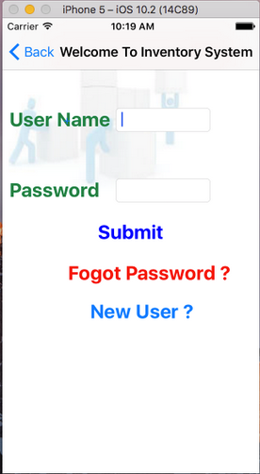

**Fig: 3.2.1 Login screen**

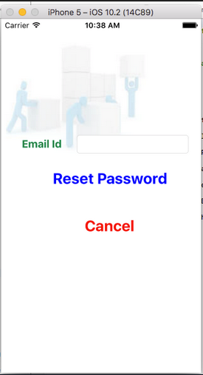

**Fig: 3.2.2 Forgot Password screen**

* 1. **Announcements Home Page:**
* Once the user successfully login into account. He/she will be directed to the Announcements page.
* The Announcements screen shows the list of all the announcements.
* When user clicks on a particular announcement, the application directs the user to the selected announcement.

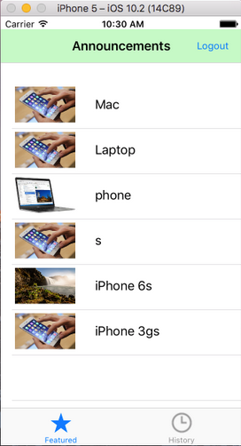

**Fig: 3.3.1 Announcements Screen**

* 1. **Select Announcement:**
* The select announcement screen shows the Announcements details
* If the user is interested to buy then he can make the required products he want to buy and click request. If the admin approves then the user can buy the required products.
* If user is not interested he clicks cancel and redirects to announcements home page

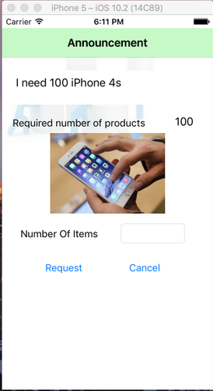 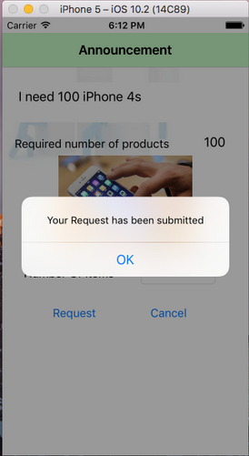

**Fig: 3.4.1 User Making announcement request**

* 1. **Upload Billing Receipt:**
* After buying the required products the user will then send the billing receipt to the admin.
* In order to do that he need to choose the file required and click submit
* The select announcement screen shows the Announcements details
* If the user is interested to buy then he can make the required products he want to buy and click request. If the admin approves then the user can buy the required products.
* If user is not interested he clicks cancel and redirects to announcements home page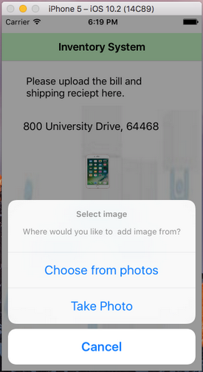 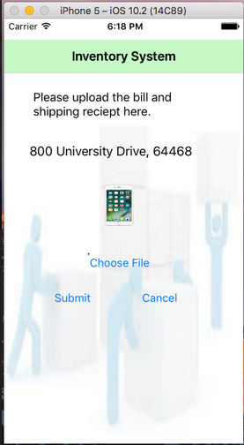

**Fig: 3.5.1 User uploading Billing receipt**

* 1. **Sending Account Details**
* After receiving the user billing receipt then the admin asks user credit details to deposit the money for the bought products
* If the user uses multiple cards for the payment then user has a addCard option to enter the multiple card information

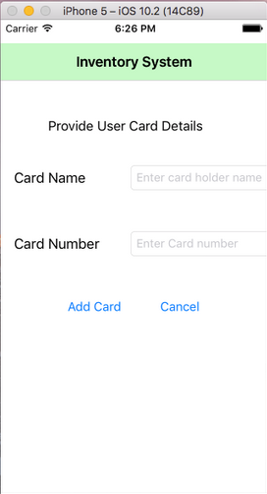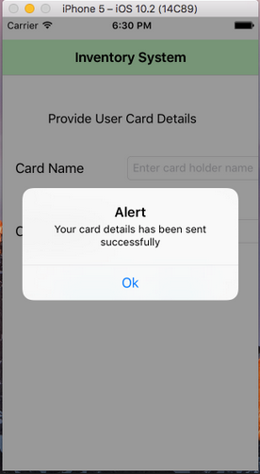

**Fig: 3.6.1 User card details**

* 1. **Payment Conformation**
* After updating the card details the admin would deposit the money to the user’s credit card and an acknowledgment will be given that the payment is initiated.

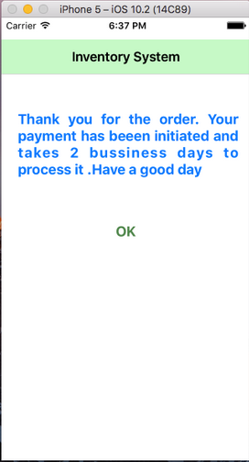

**Fig: 3.7.1 Payment Conformation page**